

ArbNet Arboretum Accreditation Application Form

The ArbNet Arboretum Accreditation Program provides standards and guidelines for the establishment and development of an arboretum. The goals of the accreditation program are to:

1) foster the establishment and professionalism of arboreta;

2) identify arboreta capable of participating or collaborating in certain scientific,   
collections, or conservation activities; and

3) advance the planting, study, and conservation of trees to improve the world.

Arboreta that are accredited are encouraged to become leaders and serve as models to promote professional development and engagement with other arboreta.

Different levels of accreditation have been established to recognize arboreta at varying degrees of development, capacity,   
and professionalism. Accredited arboreta are encouraged to continue their growth and development to achieve higher  
professional standards.

Arboreta and public gardens are eligible to apply for accreditation by submitting this form along with supporting documentation to demonstrate their level of achievement according to the specified standards. Once the application is completed, a decision will usually be made within four weeks. A site visit by an ArbNet representative may be required as part of the accreditation process.

The ArbNet Arboretum Accreditation Program is sponsored and supported by The Morton Arboretum, Botanic Gardens Conservation International (BGCI), and the American Public Gardens Association (APGA).



Please submit your completed

application via email:

**Email:** arbnet@mortonarb.org

For more information regarding

specific accreditation requirements:

**Visit:** arbnet.org/accreditation

**Call:** 630-310-7013

**Email:** arbnet@mortonarb.org

|  |  |
| --- | --- |
| Arboretum: | |
| Name of Arboretum: | **Sample Arboretum Level II** |
| Address or PO Box: |  |
| City: |  |
| State/Province: |  |
| Country: |  |
| ZIP/Postal Code: |  |
| Latitude and Longitude: |  |
| Acres: |  |
| URL: |  |

|  |  |
| --- | --- |
| Arboretum Contact (for ArbNet purposes): | |
| Name: |  |
| Title: |  |
| Email: |  |
| Phone: |  |
| Fax: |  |

|  |  |
| --- | --- |
| Individual Submitting Application (if not arboretum contact): | |
| Name: |  |
| Title: | **Arboretum Supervisor** |
| Email: |  |
| Phone: |  |
| Fax: |  |

|  |  |  |  |  |  |
| --- | --- | --- | --- | --- | --- |
| Type of organization:  *Please check all that apply:* | | | | | |
| X | Arboretum |  | Historical Site | X | Nonprofit |
|  | Garden |  | Museum |  | City Park |
|  | College |  | Cemetery |  | Town |
|  | University |  | Business |  | City |
|  | Zoo |  | Golf Course |  | Community |
|  | Other: | | | | |

|  |  |
| --- | --- |
| Authorization and Verification  The chairperson or leader of the applicant arboretum’s governing board, organizational group, or authority  (corresponding to Section I.b below) must approve this application, specifically verifying the accuracy and  authenticity of the information it contains. Approval is indicated by placement below of this individual’s  name, title or role at arboretum, and contact information.  *Authorizing/Verifying Governance Leader (other than individual submitting application):* | |
| Name: |  |
| Title: | **Executive Director** |
| Email: |  |
| Phone: |  |
| Fax: |  |

Arboretum Accreditation Standards

Accreditation standards are outlined on the website, **arbnet.org/accreditation**, and described in each of the following application sections. Please indicate which of the following standards have been met by the applicant and provide the information requested. Fulfillment of these standards is self-determined by the applicant.

**Arboretum accreditation level sought (check one): ___LEVEL I**  **_X__LEVEL II**  **___LEVEL III ___LEVEL IV**



FOUR LEVELS OF ACCREDITATION

Please use this chart as a reference. The levels of accreditation recognize arboreta with different degrees of development, capacity, and professionalism.

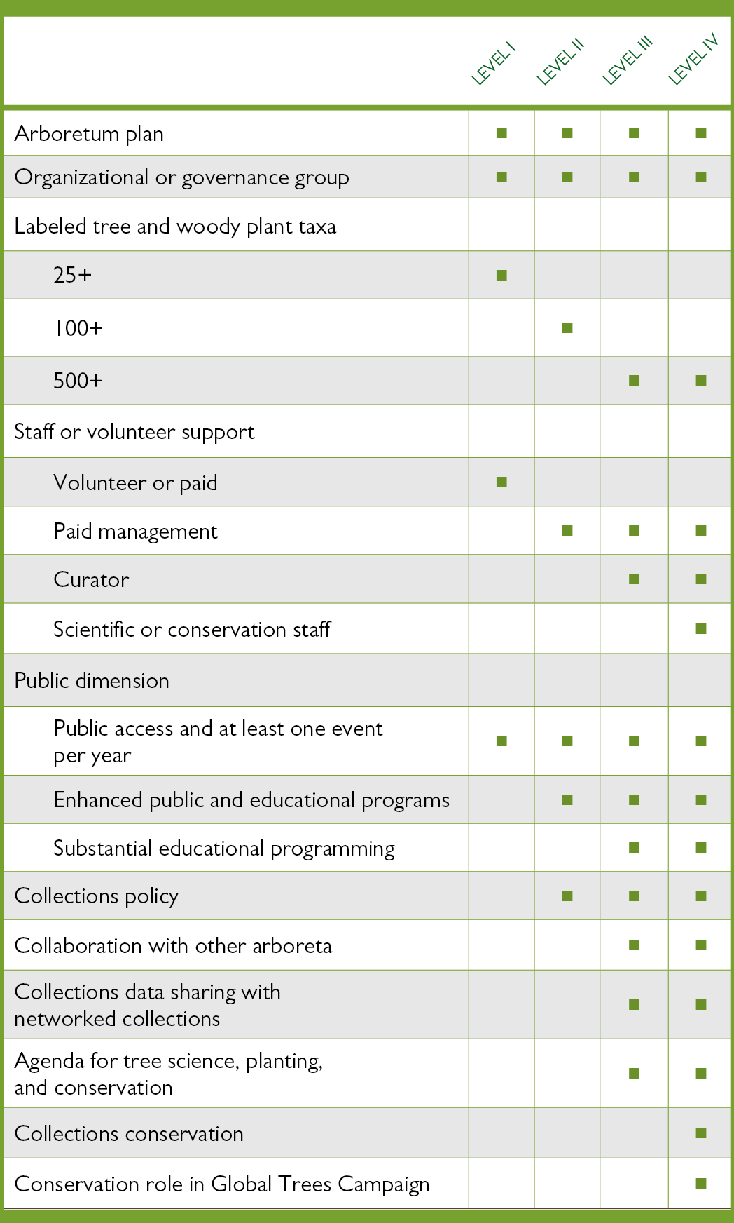

1. General Accreditation Requirements (All Levels)

|  |
| --- |
| **a. Arboretum Plan**  Documentation such as an organizational plan, strategic plan, master plan, or other, that defines the purpose of the arboretum, its audience(s), the types of plants that are to be grown to achieve that purpose and serve those audiences, provisions for the maintenance and care of the plants, and provisions for the continuing operation of the organization through time with a clear succession plan. Sample organizational plans can be found [**here**](http://arbnet.org/sites/arbnet/files/ArbNet%20Sample%20Arboretum%20Plan.pdf)on ArbNet.  *Provide a brief description or outline of the type and scope of the plan for your arboretum. Attach the Master Plan document if possible.* |
| **Mission Statement:**  *The mission of the ABC Arboretum is to provide a place of recreation, education and beauty.*  **Objectives**   * To preserve and care for the trees currently inhabiting the arboretum space * To add and care for new species, both native and exotic * To allow private or business groups and/or individuals to submit ideas, proposals or donations for the arboretum in order to encourage community involvement. * To allow approved volunteer groups and/or individuals to work in the arboretum by assisting with the care and maintenance of the trees, plants and general landscape. * To educate visitors about basic tree maintenance and care.   To celebrate trees through events within the arboretum and in the surrounding community. |
| **b. Organizational or Governance Group**  A governing board, group of people, or authority that is dedicated to the arboretum plan and its continuation beyond the efforts of a single individual. Such an organizational/governance group will affirm fulfillment of standards and authorize participation as an accredited arboretum.  *Describe the nature of your governance board or authority and the number and type of individuals involved. Attach any relevant documents or policies relating to the Governance Group.* |
| The ABC Arboretum currently has 15 Board of Directors. They meet quarterly to help the Arboretum meet its mission. The Board is represented by business, legal, medical, educational and horticulture professions. |
| **c. Arboretum Collection**  The number of tree and woody plant species being grown in accordance with the arboretum plan. Plants in the arboretum’s collection must be labeled in some way to identify them taxonomically, including scientific name and cultivar if applicable, and documented in some way so that information on their acquisition (source or origin, date of acquisition, etc.) is available for access. Minimum numbers are:  **25+ Species (Level I) 100+ Species (Level II) 500+ Species (Levels III and IV)**  *Indicate the number of trees/woody plant species in the collection and describe the method for labeling and documenting the plants. Provide the link to your collections database and indicate if it is shared in a searchable, open-access database, such as BGCI PlantSearch (http://www.bgci.org/plant_search.php). If your collection species list is not shared or accessible online, please attach the list with your application.* |
| *List any special taxonomic, geographic, ecological, or conservation collections of note* (e.g. oaks; *Acer*; dwarf conifers; halophytes; woody plants of Madagascar; etc.):  We currently have 787 trees and 114 shrubs and perennials that are labeled. We have 125 tree species. Plants are labeled with scientific and common name on a plaque that is attached to a stake and located at the base of the plant. Trees that have been purchased by donors are identified using a brass plaque. All the trees are tagged with a tree number tag and have been located using GIS and are inventoried and records of planting, pruning, insect and disease control, DBH, value, source are maintained utilizing a computer inventory program. Our collections database is not accessible on our website however we have attached the listing in a spreadsheet. We are not currently sharing the database with BGCI but will be looking into it. |



Botanical Gardens Conservation International (BGCI) is an international organization with a mission to ensure   
the conservation of threatened plants worldwide. Its global database provides information on the plants kept   
in living collections around the world. Your data will help conservationists, policy makers and planners, educators,   
and others working to save plant diversity—and can help measure the threatened plants safely in cultivation   
somewhere in the world. The location of your plants is kept hidden from Plant Search users so you will not face   
any security issues regarding rare or valuable plants.

SHARE YOUR DATA

To share your collections database with BGCI, visit: **https://www.bgci.org/resources/bgci-tools-and-resources/plantsearch-upload-instructions/**.

*Detailed instructions are provided.*



|  |
| --- |
| **d. Arboretum Staff or Volunteer Support** |
| 1. **Level I**   Employees or volunteers who ensure fulfillment of the arboretum plan and provide for the basic needs of the arboretum collection and functions of the arboretum.  *Describe the scope of staff or volunteers engaged in or supporting the work of the arboretum.* |
|  |
| 1. **Levels II, III, & IV**   One or more paid arboretum employees who have job responsibilities that specifically include management or operation  of the arboretum in fulfillment of the arboretum plan.  *Describe the staff responsible for management or operations of the arboretum, including staff dedicated to educational*  *programming for Levels III & IV.* |
| There are four full time staff members; Executive director, supervisor, Groundskeeper and groundsman. There are twelve students from the local university also employed part-time year round to assist the full time staff. Each full time staff member is responsible for caring and maintaining their assigned 1/3 section of the Arboretum with the supervisor overseeing the entire Arboretum. |
| 1. **Levels III & IV**   A dedicated curator, or curator-equivalent employee, who is focused on the care and development of the arboretum collection, in accordance with the arboretum plan and collections policy.  *Provide the name and job title of the curator or curator-equivalent employee.* |
|  |
| **e. Arboretum Public Dimension**  A public dimension that includes some level of public access, and at least one public event or educational program each year focused on trees, forest ecology, or arboretum purposes (for example, an Arbor Day observance).  *Describe how the arboretum is open or accessible to the public, and name and describe the public events or programs offered.* |
| The Arboretum is open year round and free of charge. An annual tree planting event is held on Arbor Day and is open to and advertised to the public and our College community |

2. Collections and Education (Required for Levels II, III, and IV)

|  |
| --- |
| **a. Arboretum Collections Policy**  A collections policy describes the purpose, development, and professional management of the plants in the arboretum collection, in accordance with standards developed in the public garden and museum fields. Such a policy and related practices includes a rationale for holding the particular collections of the arboretum, collections inventory, and record-keeping practices. Examples are available on the [**ArbNet website**](http://arbnet.org/sites/arbnet/files/ArbNet%20Sample%20Collections%20Policy%203%20%202014_0.pdf)**.**  *Describe and outline the elements of the collections policy and attach the document if possible.* |
| |  |  | | --- | --- | | |  | | --- | | **Administration of Collections**  This policy will be developed, approved, and amended by the Horticulture Committee. The Executive Director is responsible for the administration of the Plant Collections Policy. The staff, at the direction of the Executive Director will implement the policy. The Executive Director will be responsible for the record keeping of the collections.  The Horticulture Committee will review the Plant Collections Policy annual and make adjustments with the Board’s approval.  **Scope of Collections**  The ABC Arboretum collections will be divided into two groups:  1) Botanical Collections – Plants of taxonomic, economic, or ecological significance including endangered or rare species. These plants may be part of the applied research that is being conducted. Collections are located in the areas appropriate and consistent with established design criteria. Specific focus will be on (but not limited to) Quercus (oaks), Conifers (cone bearing trees), and Kalmia (mountain laurel) as collections designated for expansion and research.  2) Display Collections – Plants of ornamental value planted for display purposes only. Display Collections are often temporary and seasonal and may be distributed in various locations of the Arboretum to maximize their aesthetic value to the site. Display collections may also consist of container plantings.  **Acquisition –**  **Criteria**  The following criteria will be used to determine if the plant warrants addition to the Botanical Collection:  1. The taxon is particularly well –suited culturally for this facility.  2. The taxon has local significance i.e.- American chestnut, oaks, or the taxon has biological significance i.e. hemlocks resistant to the wooly adelgid  3. The taxon may be particularly deer resistant and warrants “testing”.  4. The taxon may have a particular species whose hardiness is in question and warrants “testing”.  5. The taxon, to our knowledge, has never been grown in this climate before and warrants “testing”.  6. The taxon is rare, endangered or hard to find and warrants protection.  7. The taxon can exhibit a biological phenomenon that is of particular interest to our audience.  **Policy**  The Executive Director will approve all acquisitions based on the criteria. Major acquisitions or collections must be approved by the Horticulture Committee who will recommend them to the Board.  **Accessions**  All plants acquired for the Botanical and Display Collections will be accessioned except for short-lived/annual plants. Display collections may not be accessioned. Plants that may be acquired for plant sales will not be accessioned.  **Deaccession**  The Executive Director will decide to deaccession a plant if:  1. The plant is dead or disfigured  2. The plant can be replaced by a better specimen of the same type.  Major deaccessioning changes will be presented to the Horticulture Committee for approval.  **Plant Records System and Mapping**  The ABC Arboretum is committed to maintaining a comprehensive plant records system and mapping. The Executive Director is responsible for administration and accuracy of the plant records system. Records will include species name, accession number, location, cultural comments, source, date, cost, and size when acquired, and provenance.  **Maintenance**  The Executive Director is responsible for implementing and over-seeing staff in proper plant care techniques.  **Inventory and Evaluation**  The Arboretum collections will be inventoried, mapped, measured and evaluated on a regular basis.  The evaluation should consider the following:  1) Continued fulfillment of the acquisition criteria  2) Accuracy of the nomenclature  3) Recommendations for deaccession if applicable  4) Recommendations for treatment and maintenance | | |
| **b. Enhanced Educational and Public Programming**  Enhanced or substantial educational and public programming beyond the basic level required for Level I accreditation. Programs must be related to trees (e.g. tree identification, forest ecology, conservation, collections, or some other tree-focused aspect of the arboretum mission or master plan). |
| 1. **Level II Enhanced Education Program**   *Describe the educational and public programs offered by the arboretum. Include evidence of at least two outcome-based education programs (e.g. provide program description, syllabus, hand-outs, worksheets, tour script, tour map, etc.).* |
| Arboretum tours are offered to the public and our college community free of charge. The tour covers 59 plants and the prairie garden located in the arboretum. The tours explain the origins of the arboretum, how to identify the trees and shrubs, and engage the tour members to utilize their senses, sight, smell, touch, and taste when engaging with the arboretum plants.  Our arboretum staff also participates in offering pruning and instructional classes to local garden clubs as well as being instructors in the Landscape Contractors Association pruning seminars.  The arboretum website is interactive and includes pictures as well as descriptions of some of the more unique and prominent plants in the collection. We are in the process of upgrading our arboretum website to be even more interactive so that is may be used as a tool on a smartphone, tablet, or PDA for self-guided educational tours.  We are also available to Garden Clubs and other groups for presentations. We have done and have upcoming presentations on pruning, tree selection, etc. to the Garden Club. |
| 1. **Levels III and IV Substantial Education Program**   *A substantial program of education related to trees, woody plants, forest ecology, conservation, and other related topics. Provide a description of your overarching program plan including your education program strategy, number of outcome-based education programs, and explain how they are evaluated.* |
|  |



Submit APplication

Please attach at least two photos of your arboretum (high resolution JPEG format in landscape orientation), as well as your institution's logo (JPEG format), with your application for use in the accreditation press release and on the ArbNet website.

Please submit your completed

application via email:

**Email:** arbnet@mortonarb.org

For more information regarding

specific accreditation requirements:

**Visit:** arbnet.org/accreditation

**Call:** 630-310-7013

**Email:** arbnet@mortonarb.org