

ArbNet Arboretum Accreditation Application Form

The ArbNet Arboretum Accreditation Program provides standards and guidelines for the establishment and development of an arboretum. The goals of the accreditation program are to:

1) foster the establishment and professionalism of arboreta;

2) identify arboreta capable of participating or collaborating in certain scientific,   
collections, or conservation activities; and

3) advance the planting, study, and conservation of trees to improve the world.

Arboreta that are accredited are encouraged to become leaders and serve as models to promote professional development and engagement with other arboreta.

Different levels of accreditation have been established to recognize arboreta at varying degrees of development, capacity,   
and professionalism. Accredited arboreta are encouraged to continue their growth and development to achieve higher  
professional standards.

Arboreta and public gardens are eligible to apply for accreditation by submitting this form along with supporting documentation to demonstrate their level of achievement according to the specified standards. Once the application is completed, a decision will usually be made within four weeks. A site visit by an ArbNet representative may be required as part of the accreditation process.

The ArbNet Arboretum Accreditation Program is sponsored and supported by The Morton Arboretum, Botanic Gardens Conservation International (BGCI), and the American Public Gardens Association (APGA).



Please submit your completed

application via email:

**Email:** arbnet@mortonarb.org

For more information regarding

specific accreditation requirements:

**Visit:** arbnet.org/accreditation

**Call:** 630-310-7013

**Email:** arbnet@mortonarb.org

|  |  |
| --- | --- |
| Arboretum: | |
| Name of Arboretum: | **Sample Level I Arboretum** |
| Address or PO Box: |  |
| City: |  |
| State/Province: |  |
| Country: |  |
| ZIP/Postal Code: |  |
| Latitude and Longitude: |  |
| Acres: |  |
| URL: |  |

|  |  |
| --- | --- |
| Arboretum Contact (for ArbNet purposes): | |
| Name: | Ted Tree |
| Title: |  |
| Email: |  |
| Phone: |  |
| Fax: |  |

|  |  |
| --- | --- |
| Individual Submitting Application (if not arboretum contact): | |
| Name: |  |
| Title: | **Arboretum Student Intern** |
| Email: |  |
| Phone: |  |
| Fax: |  |

|  |  |  |  |  |  |
| --- | --- | --- | --- | --- | --- |
| Type of organization:  *Please check all that apply:* | | | | | |
| X | Arboretum |  | Historical Site |  | Nonprofit |
|  | Garden |  | Museum |  | City Park |
| X | College |  | Cemetery |  | Town |
|  | University |  | Business |  | City |
|  | Zoo |  | Golf Course |  | Community |
|  | Other: | | | | |

|  |  |
| --- | --- |
| Authorization and Verification  The chairperson or leader of the applicant arboretum’s governing board, organizational group, or authority  (corresponding to Section I.b below) must approve this application, specifically verifying the accuracy and  authenticity of the information it contains. Approval is indicated by placement below of this individual’s  name, title or role at arboretum, and contact information.  *Authorizing/Verifying Governance Leader (other than individual submitting application):* | |
| Name: | **Ted Tree** |
| Title: | **Executive Director** |
| Email: |  |
| Phone: |  |
| Fax: |  |

Arboretum Accreditation Standards

Accreditation standards are outlined on the website, **arbnet.org/accreditation**, and described in each of the following application sections. Please indicate which of the following standards have been met by the applicant and provide the information requested. Fulfillment of these standards is self-determined by the applicant.

**Arboretum accreditation level sought (check one): _X__LEVEL I**  **___LEVEL II**  **___LEVEL III ___LEVEL IV**



FOUR LEVELS OF ACCREDITATION

Please use this chart as a reference. The levels of accreditation recognize arboreta with different degrees of development, capacity, and professionalism.

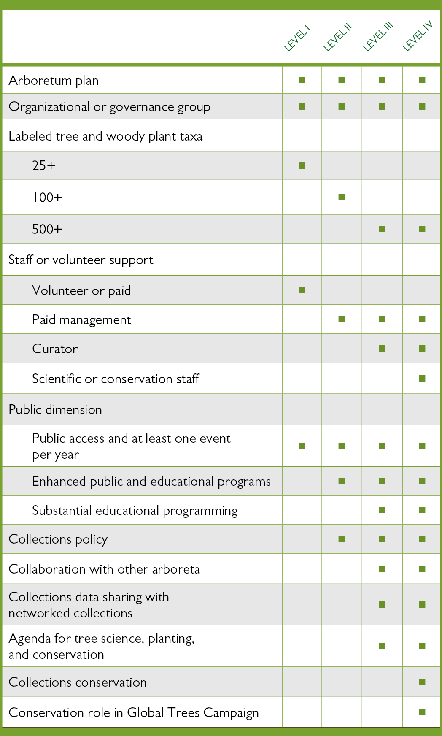

1. General Accreditation Requirements (All Levels)

|  |
| --- |
| **a. Arboretum Plan**  Documentation such as an organizational plan, strategic plan, master plan, or other, that defines the purpose of the arboretum, its audience(s), the types of plants that are to be grown to achieve that purpose and serve those audiences, provisions for the maintenance and care of the plants, and provisions for the continuing operation of the organization through time with a clear succession plan. Sample organizational plans can be found [**here**](http://arbnet.org/sites/arbnet/files/ArbNet%20Sample%20Arboretum%20Plan.pdf)on ArbNet**.**  *Provide a brief description or outline of the type and scope of the plan for your arboretum. Attach the Master Plan document if possible.* |
| The purpose of the ABC Arboretum is to celebrate, enhance and maintain the 361 acres of trees, shrubs and wildlife habitat areas of ABC College Arboretum. We propose to manage our campus acres so as to nurture and instruct young and old, teachers, students, staff, and neighbors. Plantings will reflect a goal of building collections for scientific study as well as aesthetic appreciation, with sustainable maintenance and ecological awareness as guiding principles in what we do. |
| **b. Organizational or Governance Group**  A governing board, group of people, or authority that is dedicated to the arboretum plan and its continuation beyond the efforts of a single individual. Such an organizational/governance group will affirm fulfillment of standards and authorize participation as an accredited arboretum.  *Describe the nature of your governance board or authority and the number and type of individuals involved. Attach any relevant documents or policies relating to the Governance Group.* |
| ABC Arboretum has been placed in trust to ABC College, and the college president and administration have contributed to and approved the plan as part of that trust agreement. |
| **c. Arboretum Collection**  The number of tree and woody plant species being grown in accordance with the arboretum plan. Plants in the arboretum’s collection must be labeled in some way to identify them taxonomically, including scientific name and cultivar if applicable, and documented in some way so that information on their acquisition (source or origin, date of acquisition, etc.) is available for access. Minimum numbers are:  **25+ Species (Level I) 100+ Species (Level II) 500+ Species (Levels III and IV)**  *Indicate the number of trees/woody plant species in the collection and describe the method for labeling and documenting the plants. Provide the link to your collections database and indicate if it is shared in a searchable, open-access database, such as BGCI PlantSearch (http://www.bgci.org/plant_search.php). If your collection species list is not shared or accessible online, please attach the list with your application.* |
| *List any special taxonomic, geographic, ecological, or conservation collections of note* (e.g. oaks; *Acer*; dwarf conifers; halophytes; woody plants of Madagascar; etc.): |

Our collections are just beginning to be documented, through GIS plotting and Arboretum labeling. Presently we have 30 documented tree species labeled and are in the process of documenting our top 25 woody shrub sites on campus, to label and enrich our tree tour later this year. Please find attached a document listing our collections. Additionally, here is a link to our collections online - www.abccollege/arboretum/collections.org. We do not presently share our database with BGCI.



Botanical Gardens Conservation International (BGCI) is an international organization with a mission to ensure   
the conservation of threatened plants worldwide. Its global database provides information on the plants kept   
in living collections around the world. Your data will help conservationists, policy makers and planners, educators,   
and others working to save plant diversity—and can help measure the threatened plants safely in cultivation   
somewhere in the world. The location of your plants is kept hidden from Plant Search users so you will not face   
any security issues regarding rare or valuable plants.

SHARE YOUR DATA

To share your collections database with BGCI, visit: **https://www.bgci.org/resources/bgci-tools-and-resources/plantsearch-upload-instructions/**.

*Detailed instructions are provided.*



|  |
| --- |
| **d. Arboretum Staff or Volunteer Support** |
| 1. **Level I**   Employees or volunteers who ensure fulfillment of the arboretum plan and provide for the basic needs of the arboretum collection and functions of the arboretum.  *Describe the scope of staff or volunteers engaged in or supporting the work of the arboretum.* |
| Our organizing body largely serves as volunteers. Students, alumni members, community members, and staff members are all volunteers |
| 1. **Levels II, III, & IV**   One or more paid arboretum employees who have job responsibilities that specifically include management or operation  of the arboretum in fulfillment of the arboretum plan.  *Describe the staff responsible for management or operations of the arboretum, including staff dedicated to educational*  *programming for Levels III & IV.* |
|  |
| 1. **Levels III & IV**   A dedicated curator, or curator-equivalent employee, who is focused on the care and development of the arboretum collection, in accordance with the arboretum plan and collections policy.  *Provide the name and job title of the curator or curator-equivalent employee.* |
|  |
| **e. Arboretum Public Dimension**  A public dimension that includes some level of public access, and at least one public event or educational program each year focused on trees, forest ecology, or arboretum purposes (for example, an Arbor Day observance).  *Describe how the arboretum is open or accessible to the public, and name and describe the public events or programs offered.* |
| We held four public educational programs last year with a plan to increase this year. Our workshops include: Creating and Maintaining Rain gardens, Pruning and Ecosystems Habitat Walk and Talk as well as our Arbor Day celebration event. |



Submit APplication

Please attach at least two photos of your arboretum (high resolution JPEG format in landscape orientation), as well as your institution's logo (JPEG format), with your application for use in the accreditation press release and on the ArbNet website.

Please submit your completed

application via email:

**Email:** arbnet@mortonarb.org

For more information regarding

specific accreditation requirements:

**Visit:** arbnet.org/accreditation

**Call:** 630-310-7013

**Email:** arbnet@mortonarb.org